MASTERYS GP4 60-160 kVA features now intrinsic redundancy as standard

Benfeld, August 2023
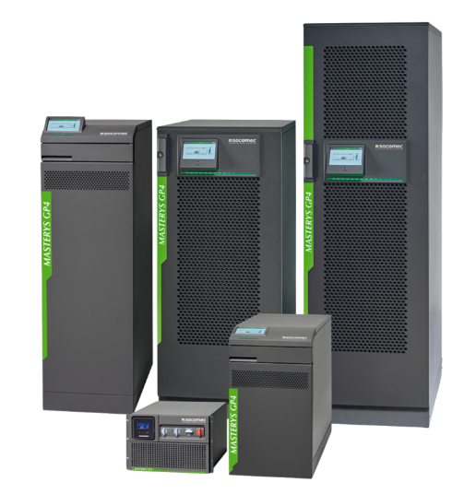
With reliability engineered-in, alongside a range of innovative features, MASTERYS GP4 is the most advanced monolithic medium power UPS solution - delivering guaranteed uptime and maximised energy efficiency combined with intelligent capability that’s fit for the future.

Tailor-made as standard, MASTERYS GP4 has been designed for optimisation. The system’s reduced footprint is compatible with existing installations and with more than 20 options available this flexible solution means that it’s now possible to, configure up to 6 units in parallel, for the ultimate adaptability.

A new feature to increase the availability

MASTERYS GP4 60-160 kVA features now intrinsic redundancy as standard.
What does it mean?
Any potential fault is detected inside the affected sub-assemblies, keeping the critical load protected in double conversion mode thanks to the remaining power converters.
The UPS comprises mechanically segregated subassemblies allow faulty components to be replaced quickly, easily and safely while in maintenance bypass mode - without disassembling the unit in order to reduce the mean time to repair (MTTR).

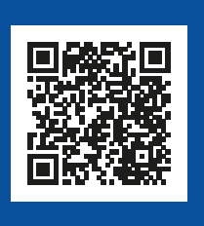
To learn more, watch the video!

The UPS is designed to provide intrinsic double conversion mode redundancy in the eventuality that a power brick is no longer available, to deliver a minimum between 50% and 75% of load depending on the product selected:

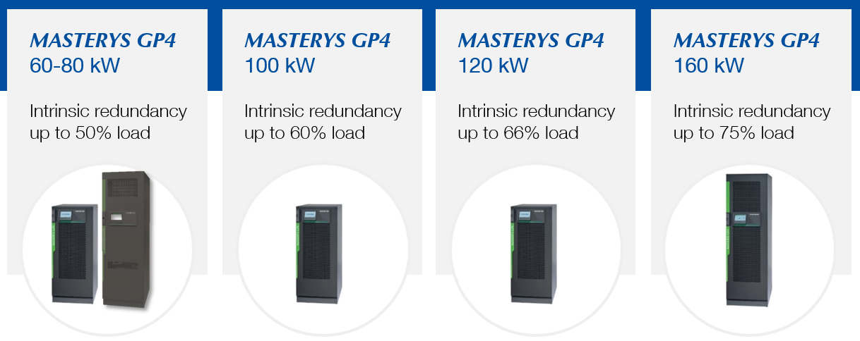

Other features are available to meet unmatched resiliency
- UPS architecture eliminates single point of failure associated with traditional monolithic UPS
- Fault tolerant concept provides double conversion mode redundancy to a minimum of 50% of rated power in the worst case scenario
- Self-sufficient power bricks
- Based on our field proven medium power platform
- Limited number of power converters - each designed to eliminate potential fault propagation for best MTBF
- Powerful and robust static bypass.

SOCOMEC: When energy matters |  | Press contact
Founded in 1922, SOCOMEC is an independent industrial group with a workforce of 3600 experts spread over 28 subsidiaries in the world. Our core business: the availability, control and safety of low voltage electrical networks serving our customers’ power performance. In 2018, SOCOMEC posted a turnover of 537M€. |  | Antonio Tamiozzo  Product Manager  + 39 0444598865  antonio.tamiozzo@socomec.com  www.socomec.co.uk

