Strengthening electric vehicle charging infrastructure – without the need for network upgrades.

City, Date xx^{th}, 2023

The latest energy storage solutions developed by Socomec – global manufacturer of electrical equipment for conversion, switching, monitoring and measurement – are strengthening electric vehicle charging infrastructure (EVCI) in uniquely demanding applications and without the need for costly network upgrades.
The expansion of decarbonisation programmes and associated legislation is leading to an increase in the overall number and usage of electric vehicles (EVs) with an upturn in demand for faster charging. EVCI providers need to manage peaks in demand, considering the impact on both profitability and performance.
Designed to address these challenges through a small and smooth modification to LV distribution, Socomec has released solutions that boost the charging capacity of EV stations through peak shaving, increased resilience, the maximisation of self-consumption and grid flexibility.

Flexible and resilient power that reduces costs
The launch of Socomec’s SUNSYS HES L - a native outdoor system that merges proven technologies to create an all-in-one solution – has set new standards in terms of product safety. The system does not require huge modifications to existing infrastructure and LV distribution – because it doesn’t need to be housed inside a building - and offers significant flexibility for future expansion.
Created from experience of UPS, PV inverters and ESS - as well as being proven in the field - the lithium-ion batteries are supplied in collaboration with leading manufacturer, CATL.
Socomec’s SUNSYS HES L system has been engineered to maintain consistent service, regardless of network saturation. Designed to overcome such constraints, particularly when combined with local renewable energy production, SUNSYS HESL maintains charging speed, even during the busiest hours. This means that the operating power of the terminals can be maximised and that the high costs and long waits associated with network upgrades can be avoided – while ensuring a more stable load. Furthermore, the system ensures continuity of service in case of loss of the main network.
Installation and operating costs are reduced as energy storage can help limit investment and accelerate the deployment of terminals – in contrast, the addition of charging stations or even one fast charging station would typically necessitate an infrastructure upgrade.
For consumers who regularly have energy needs that are greater than their subscription, storage that’s loaded during off-peak hours makes it possible to smooth consumption, known as peak clipping. Energy storage systems may even be bundled by an aggregator to provide additional revenue through grid services.
A new standard in energy storage
Designed and manufactured in Europe, the SUNSYS HES L is based on two main cabinets – a converter cabinet (SUNSYS C-Cab L) and battery cabinet (SUNSYS B-Cab L) that can be positioned in parallel, providing high flexibility and modularity for the whole system. The integrated Battery Management System is a smart automation box allowing storage functions to be stacked in order to multiply revenue and maximise savings, improving the return on investment.
Socomec comments; “This new technology enables users to overcome big obstacles in terms of electric vehicle deployment, not least because it can be easily replicated in locations where there are grid constraints. Electric vehicles and photovoltaic panels are real catalysts of the energy transition and their integration marks a new era in terms of sustainability. In delivering REN integration, energy cost savings, grid reinforcement, grid resilience and CO2 emission reduction, this system is unique in its ability to provide such a breadth of services to both the consumer and the utility.”

Discover the new outdoor energy storage system SUNSYS HES L here.

SOCOMEC: When energy matters |  | Press contact
Founded in 1922, SOCOMEC is an independent industrial group with a workforce of 3600 experts spread over 28 subsidiaries in the world. Our core business: the availability, control and safety of low voltage electrical networks serving our customers’ power performance. In 2020, SOCOMEC posted a turnover of 544,4M€.  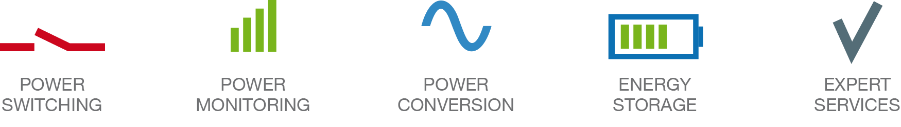 |  | Elodie HESTIN  Product Lina Marketing Manager  elodie.hestin@socomec.com  www.socomec.co.uk

